Interim Project Report (IPR)
Project Title
Mitigating Living off the Land (LotL) Attacks in Cloud Environments Using Log Analysis and Machine Learning
Student Name: Chandrika Arkesh
Course: MSc Advanced Computer Science
University: University of Hertfordshire
Module: MSc Project

Contents
Chapter 1: Project Overview 5
1.1 Background and Research Problem 5
1.2 Research Question 6
1.3 Aim of the Project 6
1.4 Project Objectives 6
1.5 Project Methdology 7
1.6 Ethical Considerations 9
1.7 Project Complexity 10
Chapter 2: Literature Review 10
2.1 Introduction 10
2.2 Living off the Land (LotL) Attacks and Insider Threat Detection 10
2.3 Log Analysis 11
2.4 Machine Learning for Intrusion Detection Systems (IDS) 11
2.5 Explainable Artificial Intelligence (XAI) 12
2.6 Comparison of Previous Studies 12
2.7 Research Gap 13
2.8 Conclusion 13
Chapter 3: Progress to Date 14
3.1 Progress Achieved 14
3.2 Work Remaining 22
3.3 Project Management 23
3.4 Evidence of Work Completed 23
Conclusion 24
Future Work 25
References 27
Appendix 29

List of Figures
Figure 1: Dataset Shape After Preprocessing 16
Figure 2: Distribution of Email Size 17
Figure 3: Distribution of Attachments 18
Figure 4: Email Activity by Hour 18
Figure 5: Email Activity by Day of the Week 19
Figure 6: Monthly Email Activity 19
Figure 7: Most Active Users 20
Figure 8: Correlation Analysis 20

List of Tables
Table 1:Comparison of Previous Studies on Machine Learning-Based Intrusion Detection and Living off the Land (LotL) Attack Detection 12

Chapter 1: Project Overview

1.1 Background and Research Problem
Cybersecurity has emerged as one of the most critical issues for organizations since enterprise IT systems have started adopting cloud computing and digital architecture. Classical cyberattacks normally use malicious code can be identified through signature-based security measures. The attackers have come up with new advanced methods that make it much harder to detect the threats (Wu et al., 2024). One of those methods is referred to as Living off the Land (LotL), which is a case when the attackers abuse the legitimate utilities of the OS and trusted applications to execute the malicious acts without being detected. LotL attacks take advantage of trusted system utilities such as PowerShell, Windows Management Instrumentation (WMI), Command Prompt (CMD), and other administrative utilities (Alzaabi & Mehmood, 2024). The legitimate utilities are often used by the system administrators in their everyday work, identifying malicious activities from the normal behavior poses an immense challenge for contemporary security solutions. Therefore, organizations need intelligent ways of detecting the attacks based on behavior analysis rather than attack signatures.
The enterprise setting is characterized by the generation of extensive logs that include email communications, authentication, file access, web browsing, and device utilization. Such logs contain essential information about the behavior of an individual that can be used in a machine learning process to determine the activities that deviate from the normal ones and could point out possible insider threats or the use of Living off the Land technique of cyberattacks (Lu et al., 2024). The CERT Insider Threat Dataset contains realistic enterprise email communication records to facilitate behavioral analysis of employees' actions. Despite the fact that the data set is devoted to the insider threat, not the execution of the Windows command, the abnormal behavior in terms of excessive communication, large size of attachment files, late night time activities, and recipient's abnormal behavior can help detect possible suspicious activity, which accompanies cyberattacks (R M & M K, 2023).Therefore, behavioural log analysis combined with machine learning offers a promising approach for detecting anomalous activities before significant damage occurs.
Research Problem
Traditional security solutions operate on the principle of known malware signatures and attack rules. For this reason, such systems cannot efficiently identify Living off the Land attacks, as they use system utilities for performing the attack actions. As a result of this approach, traditional solutions have high levels of false-negative rates because the attack uses legitimate tools for administration purposes. Despite the rich amount of user activity logs generated by enterprise companies, the information contained in those files is underused for detecting the anomalies in user behaviour. For this reason, the development of smart machine learning methods for analysing enterprise logs and detecting anomalous user behavior is important. The current project deals with the analysis of enterprise emails from the CERT Insider Threat Dataset using machine learning algorithms.

1.2 Research Question
Main Research Question
How can log analysis and machine learning techniques improve the detection of Living off the Land (LotL) attacks in Windows and cloud environments?
Sub Research Questions
- Which behavioural features extracted from enterprise email logs are most useful for identifying suspicious user activities?
- Which machine learning algorithm provides the highest detection performance for behavioural anomaly detection?
- How can feature engineering improve the effectiveness of machine learning models for identifying suspicious email behaviour?

1.3 Aim of the Project
The aim of this project is to develop a machine learning-based behavioural analysis framework capable of detecting suspicious user activities by analysing enterprise email logs. The proposed solution seeks to improve the detection of Living off the Land-related behaviours and insider threats through feature engineering and supervised machine learning techniques.

1.4 Project Objectives
The objectives of this project are:
- To study Living off the Land attack techniques and behavioural characteristics.
- To investigate enterprise email communication patterns associated with suspicious user behaviour.
- To preprocess and clean large-scale enterprise log data for machine learning applications.
- To perform exploratory data analysis to understand user communication behaviour.
- To engineer meaningful behavioural features from email communication logs.
- To develop machine learning models capable of classifying suspicious and normal user behaviour.
- To compare the performance of multiple machine learning algorithms using standard evaluation metrics.
- To recommend an effective behavioural detection approach for enterprise cybersecurity.

1.5 Project Methdology
The proposed project is based on the methodology CRISP-DM (Cross Industry Standard Process for Data Mining), where data mining solutions are created using a structured approach.
Business Understanding: The task of this project is to analyze the problem of detection of malicious behavior of users in enterprises through behavioral logging. The goal is to enhance cybersecurity through detection of anomalous communication behaviors that could be related to insider threats and Living off the Land actions.
Data Understanding: The dataset chosen for the current project is the CERT Insider Threat Dataset available on Kaggle. The selected dataset is email.csv, consisting of around 2.63 million email entries from January 2010 to May 2011.
Each record contains:
- Email identifier
- Date and time
- User ID
- Computer ID
- Sender information
- Recipient information
- CC recipients
- BCC recipients
- Email size
- Number of attachments
- Email content
This dataset represents enterprise communication behaviour suitable for behavioural analysis using machine learning.
Data Preparation
Several preprocessing operations have already been completed.
These include:
- Loading the dataset into Python.
- Converting date attributes into datetime format.
- Extracting temporal features including year, month, day, hour, minute, and day of the week.
- Removing duplicate records.
- Handling missing values in CC and BCC fields.
- Performing exploratory data analysis.
- Engineering behavioural features including:
  - Number of recipients
  - External email detection
  - Large email indicator
  - Weekend activity
  - Attachment indicator
  - Email content length
Machine Learning
The following machine learning algorithms will be implemented and compared:
- Logistic Regression
- Random Forest
- XGBoost
- One-Class Support Vector Machine (One-Class SVM)
These algorithms will learn behavioural patterns from enterprise email logs to distinguish between normal and suspicious user activities.
Evaluation
The developed models will be evaluated using:
- Accuracy
- Precision
- Recall
- F1-Score
- ROC-AUC
- Confusion Matrix
The most effective model will be selected based on these performance measures.
Tools and Technologies
The project is implemented using:
- Python
- Google Colab
- Pandas
- NumPy
- Matplotlib
- Seaborn
- Scikit-learn
- XGBoost

1.6 Ethical Considerations
These factors are critical in this research to ensure responsible handling of data and ethical standards in research.
Legal Issues: CERT Insider Threat Database is publicly available via Kaggle and is used extensively for research purposes. Thus, there is no need for collecting any personal data from humans and there is no requirement for ethical approval in data collection process.
Privacy and Confidentiality: The database includes anonymous identifiers for employees instead of their actual personal details. Any attempt to trace individuals or organizations included in the database is not planned.
Professional Responsibility: Machine learning models will only be used for academic research purposes in order to increase cybersecurity awareness and not to do anything malicious.
Social Considerations: Behavioral anomaly detection may help companies recognize potential insider threats early enough in order to save money and improve information security. It is necessary to consider the issue of false positives and to avoid any unfair assessments of user's behavior.

1.7 Project Complexity
The current research fulfils all criteria to become a dissertation of MSc as it includes cybersecurity, machine learning, behavioral analytics, and big data processing. In this study, analyze around 2.63 million enterprise email transactions, which need proper data pre-processing and feature engineering. Machine learning algorithms will be used in this study and tested based on their performance metrics. Several technical issues are likely to emerge during the study such as processing of a big dataset, finding relevant behavioral features, tackling class imbalance, and distinguishing normal users' actions from malicious ones (Tian et al., 2023). However, the current solution has a certain practical application in cybersecurity of enterprises.

Chapter 2: Literature Review

2.1 Introduction
(Govindarajan and Muzamal, 2025).

2.2 Living off the Land (LotL) Attacks and Insider Threat Detection
Living off the Land (LotL) attacks have become a major cybersecurity concern because attackers misuse legitimate system utilities to evade traditional signature-based detection systems (Zhu et al., 2026). Zhu et al. (2026) proposed a feature fusion framework that improved LotL attack detection through behavioural analysis. Similarly, Alzaabi and Mehmood (2024) highlighted the effectiveness of machine learning for insider threat detection but identified challenges such as class imbalance and limited labelled datasets. Likewise, Wang et al. (2023) demonstrated that deep clustering enhances behavioural anomaly detection. However, existing studies rarely integrate enterprise log analysis with multiple machine learning models for detecting LotL attacks in cloud environments, creating a clear research gap addressed by this study (Govindarajan and Muzamal, 2025)..

2.3 Log Analysis
Log analysis in enterprises is one of the primary methods used to detect abnormal user behavior and cyber threats through event analysis produced by the systems. In their work, Li et al. (2025) showed that the application of contrastive learning using retrieval can improve anomaly detection by contextualizing the log data, while Tian et al. (2023) introduced the CLDTLog framework that leverages contrastive learning with dual-task objectives to create stronger representations of the logs. On the other hand, Manzoor et al. (2024) examined various open-source SIEM products and showed their effectiveness in collecting and analyzing enterprise logs for detecting threats in real-time.

2.4 Machine Learning for Intrusion Detection Systems (IDS)
There have been many improvements in IDS due to the application of machine learning in the detection of complex cyber attacks that are not identified by the traditional signature-based approaches. For instance, Attou et al. (2023) developed a cloud-based IDS system that used machine learning algorithms to detect attacks successfully. Lu et al. (2024) improved the Random Forest algorithm by performing feature optimization, leading to improved classification as compared to the traditional Random Forest algorithm. On the other hand, R M and M K (2023) applied the use of hybrid deep learning algorithms in AWS cloud intrusion detection, proving that deep learning is more efficient in detecting attacks, though at higher computational costs.
Recent studies have utilized advanced methods like graph learning, explainable artificial intelligence, and anomaly detection in order to enhance IDS performance. Govindarajan & Muzamal (2025) developed a graph transformer model that used contrastive learning to produce outstanding cloud intrusion detection. Hosain & Çakmak (2025) and Hu et al. (2026) showed that XGBoost with explainability not only improves prediction but also makes models more interpretable. Similarly, Ayad et al. (2024) designed a one-class autoencoder able to detect unknown attacks when labeled data is insufficient. Even though these studies present impressive findings, they all seem to be related to cloud or IoT networks and not enterprise log analysis, pointing out to the necessity to assess several machine learning methods for detecting LoL attacks in clouds.

2.5 Explainable Artificial Intelligence (XAI)
Explainable Artificial Intelligence (XAI) has increased the transparency of machine learning algorithms because of the possibility for security experts to comprehend how the algorithm makes intrusion detection choices. The work done by Hosain and Cakmak (2025) shows that XAI-XGBoost not only improves the accuracy of detection but also makes the algorithm more understandable. In addition, Hu et al. (2026) applied interpretability analysis to the XGBoost algorithm.

2.6 Comparison of Previous Studies
The Table 2.1 outlines the main characteristics of the examined articles and includes such information as the research purpose, methodology, results obtained, and limitations identified. This table reflects both similarities and disparities between various approaches and serves as the basis for identifying the research gap.
Table 1:Comparison of Previous Studies on Machine Learning-Based Intrusion Detection and Living off the Land (LotL) Attack Detection
Author (Year) | Topic and Method | Key Findings / Interpretation | Limitation
Attou et al. (2023) | Cloud IDS using ML | Improved cloud intrusion detection accuracy using ML classifiers | Limited evaluation on advanced attacks such as LotL
Wang et al. (2023) | Deep clustering for insider threats | Improved behavioural anomaly detection from multi-source events | Focused on insider threats rather than LotL attacks
Alzaabi and Mehmood (2024) | Review of ML for insider threats | Behavioural ML outperformed rule-based detection | Class imbalance and limited labelled datasets
Lu et al. (2024) | Enhanced Random Forest IDS | Achieved higher classification accuracy through feature optimisation | Performance depends on feature engineering
Li et al. (2025) | Contrastive learning for log analysis | Improved contextual understanding of system logs | Computationally intensive framework
Govindarajan and Muzamal (2025) | Graph transformer cloud IDS | Captured complex cloud attack relationships with high accuracy | Requires significant computational resources
Hosain and Çakmak (2025) | Explainable XGBoost | Improved detection accuracy with interpretable predictions | Evaluated only in IoMT environments
Zhu et al. (2026) | LotL detection using feature fusion | Specifically addressed Living off the Land attacks with high detection capability | Limited validation using enterprise cloud log datasets

2.7 Research Gap
The literature review shows significant advancements in the application of machine learning techniques to intrusion detection, log analysis, and insider threats (Attou et al., 2023; Lu et al., 2024; Wang et al., 2023). The recent literature has further advanced anomaly detection based on contrastive learning and behaviour analytics (Tian et al., 2023; Li et al., 2025) and explainable AI has helped make intrusion detection more transparent (Hosain and Çakmak, 2025; Hu et al., 2026). While Zhu et al. (2026) focused on Living off the Land attacks, there has not been much research conducted about integrating enterprise log analysis with various machine learning models in order to detect LotL attacks in cloud-based environments. That is why, this research develops and tests various machine learning algorithms for improving LotL attacks detection based on enterprise logs.

2.8 Conclusion
From the literature review, can observe that machine learning, behavioral analysis, and log analysis become increasingly important in improving cybersecurity and intrusion detection. While current studies have offered various detection methodologies, there are still challenges in detecting Living off the Land attacks. The identified issues serve as an excellent basis for the proposed research methodology and modeling approach.

Chapter 3: Progress to Date
In this chapter, the progress made in the process of development of the project is outlined. The list of activities already performed, the method applied, activities still needed to be done and the general project management strategy are described. The project has reached the stage when all the preliminary stages have been successfully accomplished using the CRISP-DM methodology.

3.1 Progress Achieved
The project has achieved considerable progress in the initial phase of its development. Nearly 160 hours have been devoted to analyzing the research problem, studying related literature, gathering the dataset, applying data preprocessing techniques, conducting exploratory data analysis, developing informative features, and drafting the Interim Project Report (IPR). The work done is outlined below.
3.1.1 Literature Review and Topic Understanding
Literature review was conducted to achieve an in-depth insight into LotL attacks, enterprise log analysis, and machine learning for intrusion detection. Fifteen recent papers accessible through open journals have been carefully analyzed for comparison of existing LotL detection techniques, behavioral analysis techniques, and machine learning algorithms. The review highlighted the advantages and disadvantages of existing methods and found out that only a few studies are conducted on the integration of enterprise log analysis with machine learning techniques for detecting LotL attacks in cloud environment. These insights helped in formulating research objectives, defining project scope and research gap.
3.1.2 Dataset Collection
The chosen dataset was the CERT Insider Threat Dataset, provides enterprise user activity logs that can be used in behavioral analytics. The dataset was downloaded via Kaggle API on Kaggle and was unzipped in the Google Colab environment. The chosen dataset file is:
email.csv
Dataset characteristics include:
- Approximately 2.63 million email records
- Data collected between January 2010 and May 2011
- Eleven primary attributes describing enterprise email communication.
The dataset contains:
- User identifier
- Date and time
- Computer identifier
- Sender information
- Recipient information
- CC recipients
- BCC recipients
- Email size
- Number of attachments
- Email content
This dataset provides sufficient behavioural information for analysing communication patterns and identifying potentially suspicious activities.
3.1.3 Development Environment Setup
The project environment has been successfully configured using Google Colab. The following Python libraries were installed and imported:
- Pandas
- NumPy
- Matplotlib
- Seaborn
- Scikit-learn
- Kaggle API
Google Colab was selected because it provides sufficient computational resources for processing a large dataset containing more than 2.6 million records.
3.1.4 Data Understanding
The dataset was explored to understand its structure and quality. The following tasks were completed:
- Displayed sample records.
- Examined dataset dimensions.
- Identified attribute names.
- Verified data types.
- Generated descriptive statistics.
- Analysed missing values.
The dataset contains:
- 2,629,979 records
- 11 original features
Figure 1: Dataset Shape After Preprocessing
Only the CC and BCC attributes contained missing values, while all remaining features were complete. Descriptive statistical analysis showed that email sizes range from approximately 6 KB to 142 KB, while the number of attachments ranges from 0 to 9.
3.1.5 Data Preprocessing
Several preprocessing techniques were applied before performing machine learning analysis. The completed preprocessing tasks include:
- Conversion of the date column into datetime format.
- Extraction of temporal information including:
  - Year
  - Month
  - Day
  - Hour
  - Minute
  - Day of the week
- Duplicate record detection.
- Missing value handling.
- Replacement of missing CC and BCC values with "None".
These preprocessing operations prepared the dataset for further behavioural analysis.
3.1.6 Exploratory Data Analysis (EDA)
Exploratory Data Analysis was performed to understand user communication behaviour and identify useful behavioural patterns. The following visualisations were created:
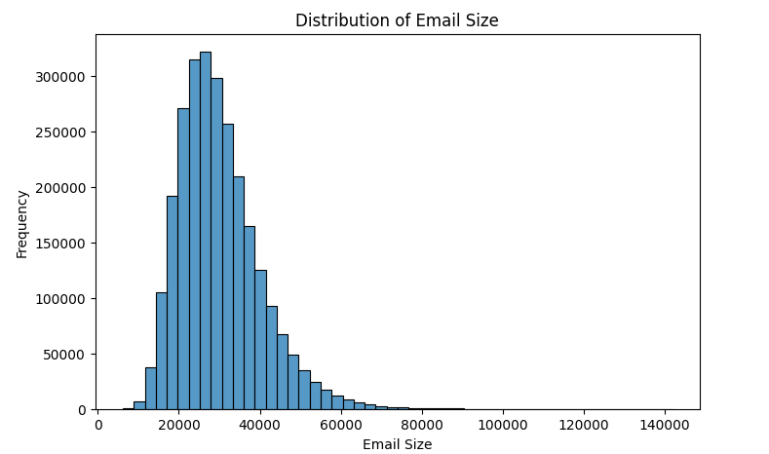
Figure 2: Distribution of Email Size
A histogram was generated to analyse the distribution of email sizes. The analysis showed that most enterprise emails contain relatively small amounts of data, while only a small proportion have unusually large sizes.
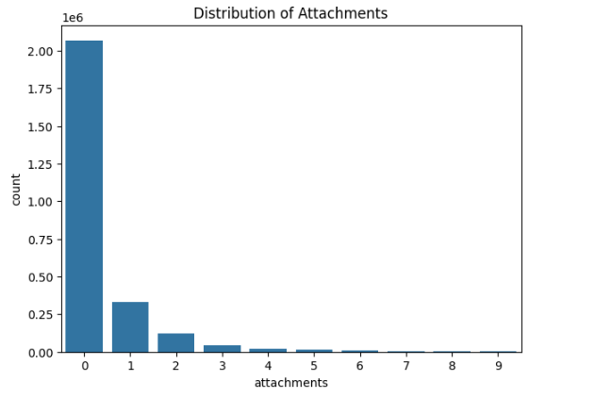
Figure 3: Distribution of Attachments
A count plot was created to examine attachment usage. The results specify that the majority of emails do not contain attachments, while only a limited number include one or more attached files.
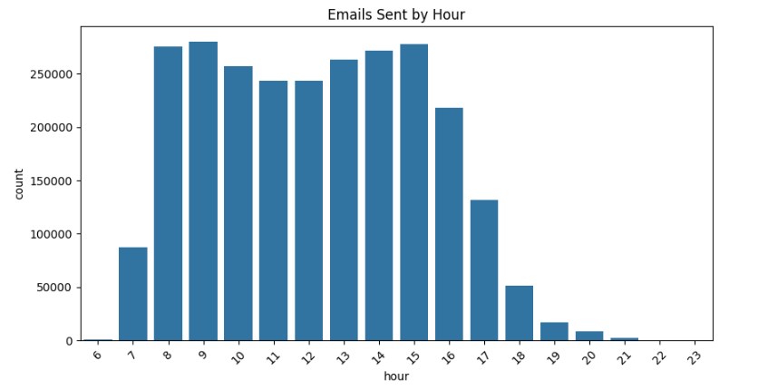
Figure 4: Email Activity by Hour
A count plot was used to analyse email activity throughout the day. The analysis revealed that email communication is concentrated during standard working hours, with fewer emails being sent during late-night periods.
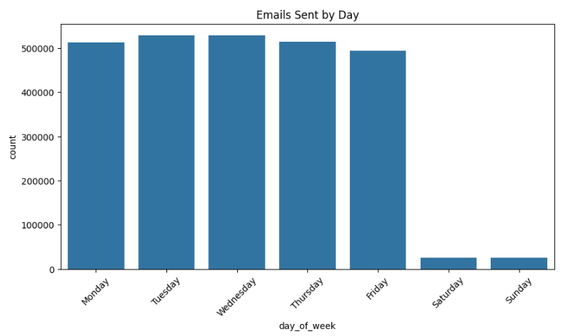
Figure 5: Email Activity by Day of the Week
Weekly communication behaviour was analysed. Most emails were sent on weekdays, while considerably fewer emails were observed during weekends.
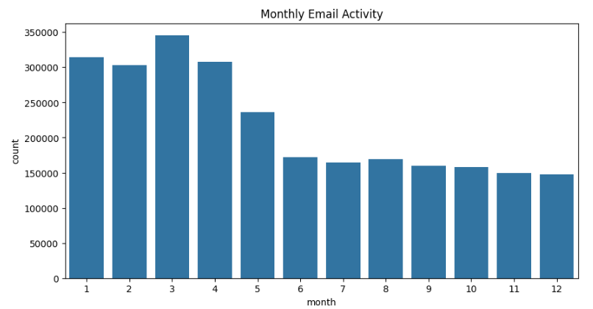
Figure 6: Monthly Email Activity
Monthly communication trends were visualised. The analysis showed variations in communication volume across different months, reflecting changing organisational activity.
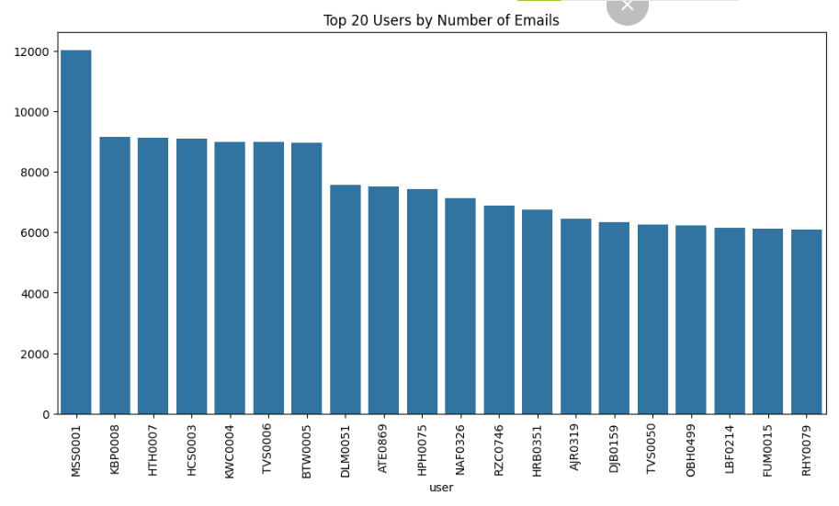
Figure 7: Most Active Users
The twenty most active users were identified based on the total number of emails sent. This analysis highlights users with exceptionally high communication activity that may require further behavioural investigation.
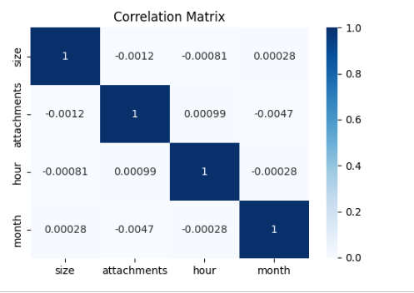
Figure 8: Correlation Analysis
Heatmap of the correlation was produced based on numeric variables. It showed rather low correlations between email size, attachments number, month, and hour, implying that several behavioral characteristics are needed to detect anomalies.
3.1.7 Feature Engineering
Feature Engineering was done to construct more behavioral features which will assist to enhance machine learning algorithms. The following features were engineered.
Recipient Count: The number of recipients in the To, CC and BCC fields was counted. These features depict complexity of communications.
Total Recipients: The number of total email recipients was calculated by summing up all the recipient fields. This feature identifies mass emails communications.
External Email indicator: A binary feature was engineered to identify emails sent externally from the organisational domain. External communications might be used for data leakage and unusual activities.
Large Email indicator: Emails having sizes more than 95th percentile were termed as large emails. This feature helps to detect unusual large email data transfers.
Weekend Communication: A binary feature was engineered to find out weekends communication i.e. emails sent on Saturdays and Sundays. Weekends communication is unusual user behavior based on organisational policies.
Attachment Feature: A binary feature was engineered to find out the presence of one or more attachments in an email. Attachments are mostly related to information sharing and data exfiltration activities.
Email Content Length: The total number of characters present in an email was calculated. Longer email content may indicate different communication
3.1.8 Current Progress Summary
At the current stage, the following tasks have been successfully completed:
- Literature review
- Project planning
- Dataset collection
- Environment setup
- Data understanding
- Data preprocessing
- Missing value handling
- Exploratory Data Analysis
- Feature Engineering
- Interim Project Report preparation
The dataset is now fully prepared for machine learning implementation.

3.2 Work Remaining
The remaining work focuses on developing, evaluating, and documenting the machine learning solution. The following activities are planned.
Machine Learning Implementation
The following machine learning algorithms will be developed:
- Logistic Regression
- Random Forest
- XGBoost
- One-Class Support Vector Machine (One-Class SVM)
Model Evaluation
Each model will be evaluated using:
- Accuracy
- Precision
- Recall
- F1-Score
- ROC-AUC
- Confusion Matrix
The best-performing model will be selected for further analysis.
Result Analysis
The experimental results will be analysed to compare model performance.
The strengths and limitations of each algorithm will be discussed.
Dissertation Writing
The remaining dissertation chapters will be completed, including:
- Literature Review
- Methodology
- Experimental Results
- Discussion
- Conclusion
- Future Work

3.3 Project Management
The project has followed the schedule as per plan. The first phase of the project involving topic choice, literature review, data collection, data preprocessing, exploratory data analysis, and feature extraction is completed successfully. The subsequent phase of the project involves modeling using machine learning techniques, analyzing and interpreting the results before the completion of the dissertation. A Gantt chart has been created for tracking the progress of the project.

3.4 Evidence of Work Completed
Evidence supporting the completed work includes:
- Download and extraction of the CERT Insider Threat Dataset.
- Python implementation in Google Colab.
- Data preprocessing scripts.
- Missing value analysis.
- Date and time feature extraction.
- Exploratory Data Analysis visualisations.
- Feature engineering implementation.
- Generated behavioural features for machine learning.
The steps taken for implementation reflect the project's transition from conceptual planning to data preparation for machine learning, ensuring a solid foundation for the next phase of development. This chapter gave an account of the advances made in the project. The CERT Insider Threat Dataset was collected and prepared for analysis. Data pre-processing, exploratory data analysis and feature engineering are done and a structured dataset for behavioural modelling is created. The next step in the project will be to deploy machine learning algorithms, test their performance, and assess how well they are working to identify suspicious user activity that might involve an insider threat, or behavior that could be a component of a Living off the Land attack.

Conclusion
This Interim Project Report has presented the progress made towards developing a machine learning-based approach for detecting suspicious user behaviour using enterprise email logs. The project aims to analyse behavioural patterns which can be sign that a user is involved in Living on the Land (LotL) or an insider threat. The project has so far successfully finished the first steps of the CRISP-DM methodology. The materials in this research were compiled through a thorough literature review, which aimed to familiarize the researcher with the research problem and current methods of behavioural detection in the field. The CERT Insider Threat Dataset was chosen as the primary source of data because it includes realistic enterprise email communication data that is appropriate for behavioral analysis.
The data was successfully loaded into the Google Colab environment and then it was preprocessed to ensure data quality. Missing values in data was addressed, temporal features were extracted, duplicate data was checked, and exploratory data analysis was conducted to gain insight into communication patterns. Additionally, a few behavioural properties were built, such as recipient count, external e-mail detection, attachment indicators, weekend activity, identification of large e-mails, and content length. These features can deliver valuable information that can enhance the efficacy of the machine learning models.
The project's completed work provides an excellent foundation for the subsequent project phases. The next phase will focus on developing and evaluating multiple machine learning models to identify suspicious user behaviour. Evaluation metrics will be compared with the results to identify the best possible approach for behavioral anomaly detection in enterprise settings. However, the project is on track and will help develop behavioural threat detection techniques through the use of machine learning.
Challenges Encountered
There were a number of challenges during the project's start-up. The first challenge was to process a very large dataset of about 2.63 million email records. To ensure minimal memory utilization and computational time, efficient data loading and preprocessing methods were needed. Another problem was the missing data in the CC and BCC fields. Measures were taken to ensure that missing values did not impact later analyses (appropriate preprocessing techniques). Another challenge was the feature engineering, in the sense that the original dataset does not have a behavioural indicator directly. Other additional features like recipient count, external communication, weekend activity and large email identification had to be created from the available data. Another restriction is there are no explicit labels marking malicious or suspicious emails. Therefore, appropriate machine learning techniques need to be carefully chosen in the subsequent phase of the project. Overcoming the above challenges, the project successfully went through the pre-processing and exploratory analysis phases, making it possible to move forward with model development.
Project Complexity
The project is multidisciplinary, technically complex and meets the requirements for a Masters by Research dissertation. The project combines ideas and methods from behavioural analytics, cybersecurity, data mining and machine learning. Efficient preprocessing techniques, feature engineering and computational optimisation are needed to handle over 2.6 million enterprise email records. Unlike traditional classification problem, behavioural threat detection must be interpreted by analysing the user's activities rather than just relying on a set of attack signatures. To detect suspicious communication patterns, meaningful behavioral features need to be extracted first to feed into machine learning algorithms. The project also includes the comparison of several machine learning methods, the assessment of the algorithms with various statistical measures and the analysis of their pros and cons for the application of cybersecurity. The proposed framework is practical because behavioural monitoring is a growing practice to detect insiders, mitigate security threats, and enhance enterprise cybersecurity.

Future Work
The remaining stages of the project will focus on implementing and evaluating machine learning models capable of detecting suspicious user behaviour.
The following activities are planned:
- Perform additional feature engineering to improve behavioural representation.
- Prepare the dataset for machine learning by encoding categorical variables and selecting relevant features.
- Develop multiple machine learning models, including Logistic Regression, Random Forest, XGBoost, and One-Class Support Vector Machine.
- Compare the performance of the implemented models using Accuracy, Precision, Recall, F1-Score, ROC-AUC, and Confusion Matrix.
- Analyse the experimental results and identify the most effective behavioural detection model.
- Interpret the findings in relation to previous research.
- Complete the final dissertation chapters, including Results, Discussion, Conclusion, and Future Recommendations.
These activities will complete the development and evaluation of the proposed behavioural detection framework.

References
Alzaabi, F.R. and Mehmood, A. (2024). A Review of Recent Advances, Challenges, and Opportunities in Malicious Insider Threat Detection Using Machine Learning Methods. IEEE Access, [online] 12, pp.30907–30927. doi: https://doi.org/10.1109/ACCESS.2024.3369906.
Attou, H., Guezzaz, A., Benkirane, S., Azrour, M. and Farhaoui, Y. (2023). Cloud-Based Intrusion Detection Approach Using Machine Learning Techniques. Big Data Mining and Analytics, 6(3), pp.311–320. doi: https://doi.org/10.26599/BDMA.2022.9020038.
Ayad, A.G., El-Gayar, M.M., Hikal, N.A. and Sakr, N.A. (2024). Efficient Real-Time Anomaly Detection in IoT Networks Using One-Class Autoencoder and Deep Neural Network. Electronics, [online] 14(1), pp.104–104. Doi :https://doi.org/10.3390/electronics14010104.
Govindarajan, V. and Junaid Hussain Muzamal (2025). Advanced cloud intrusion detection framework using graph based features transformers and contrastive learning. Scientific Reports, [online] 15(1). doi: https://doi.org/10.1038/s41598-025-07956-w.
Hosain, Y. and Çakmak, M. (2025). XAI-XGBoost: An innovative explainable intrusion detection approach for securing internet of medical things systems. Scientific Reports, [online] 15(1). doi: https://doi.org/10.1038/s41598-025-07790-0.
Hu, Y., Xiao, K., Luo, L. and Chen, L. (2026). An XGBoost-Based Intrusion Detection Framework with Interpretability Analysis for IoT Networks. Applied Sciences, [online] 16(2), p.980. doi: https://doi.org/10.3390/app16020980.
Li, W., Wu, Y., Huang, W., Zhou, F., Ou, W., Wang, H. and Deng, L. (2025). System log anomaly detection based on contrastive learning and retrieval augmented. Scientific Reports, [online] 15(1), pp.38370–38370. doi: https://doi.org/10.1038/s41598-025-22208-7.
Lu, C., Cao, Y. and Wang, Z. (2024). Research on Intrusion Detection Based on an Enhanced Random Forest Algorithm. Applied sciences, 14(2), pp.714–714. doi: https://doi.org/10.3390/app14020714.
Manzoor, J., Waleed, A., Jamali, A.F. and Masood, A. (2024). Cybersecurity on a budget: Evaluating security and performance of open-source SIEM solutions for SMEs. PloS one, [online] 19(3), pp.e0301183-e0301183. doi: https://doi.org/10.1371/journal.pone.0301183.
R M, B. and M K, J.K. (2023). Intrusion Detection on AWS Cloud through Hybrid Deep Learning Algorithm. Electronics, 12(6), p.1423. doi: https://doi.org/10.3390/electronics12061423.
Rusanov, M., Babenko, M. and Lapina, M. (2026). Optimization of Machine Learning Algorithms with Distillation and Quantization for Early Detection of Attacks in Resource-Constrained Systems. [online] Mdpi.com. Available at: https://www.mdpi.com/2504-2289/9/12/303
Tian, G., Nurbol Luktarhan, Wu, H. and Shi, Z. (2023). CLDTLog: System Log Anomaly Detection Method Based on Contrastive Learning and Dual Objective Tasks. Sensors, 23(11), pp.5042–5042. doi: https://www.mdpi.com/1424-8220/23/11/5042.
Wang, J., Sun, Q. and Zhou, C. (2023). Insider Threat Detection Based on Deep Clustering of Multi-Source Behavioral Events. Applied Sciences, [online] 13(24), p.13021. doi: https://doi.org/10.3390/app132413021.
Wu, M.-H., Hsu, F.-H., Huang, J.-H., Wang, K., Hwang, Y.-L., Wang, H.-J., Chen, J.-X., Hsiao, T.-C. and Yang, H.-T. (2024). Enhancing Linux System Security: A Kernel-Based Approach to Fileless Malware Detection and Mitigation. Electronics, 13(17), pp.3569–3569. doi: https://doi.org/10.3390/electronics13173569.
Zhu, T., Zheng, J., Chen, T., Lv, M., Xiong, C., Weng, Z. and Zheng, X. (2026). Lotldetector: Living off the land attacks detection system based on feature fusion. Cybersecurity, 9(1). doi: https://doi.org/10.1186/s42400-025-00531-w.

Appendix
